2019 Merchandise Request Form

Each event organiser will receive a complimentary merchandise pack to the value of €25 including: 4 x posters with space for event details, 4 x General CW Posters (with no space for event details), 20 x A5 fliers, 5 x CW Pens, 5 x CW Phone Ring, 4 x CW balloons and 10 x CW stickers. Orders for additional merchandise will be charged as per the rates below which include handling, packaging and posting costs.
Organisation Name:
Contact Name:
Contact Number:
Contact E-mail:
Address:
Merchandise | Image | Quantity Required | Unit Cost | Total Cost
Coffee Cup - 350 ml insulated tumbler, (new item) | 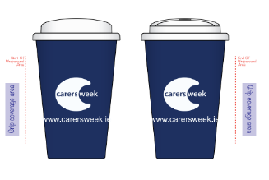 |  | €8.99
Pens (new model) | 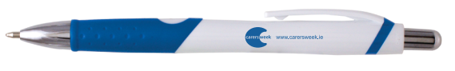 |  | €0.99c
Phone Ring/€1 Trolley Coin, (new item) |  |  | €1.49
Balloons |  |  | €0.50c
Stickers | 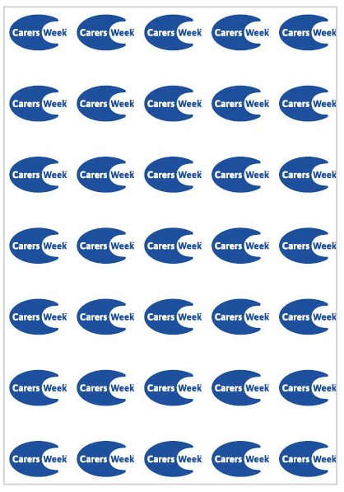 |  | €0.05c
Posters – A4 size with Large Blank Space in centre of Poster for Event Details (Previous Years Images only for Ref.) | 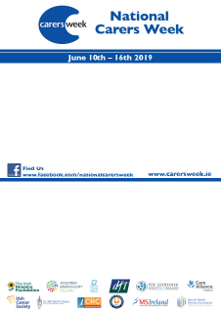 |  | €0.50c
Posters - A4 size General Carers Week Posters with no space for event details (Previous Years Images only for Ref.) | 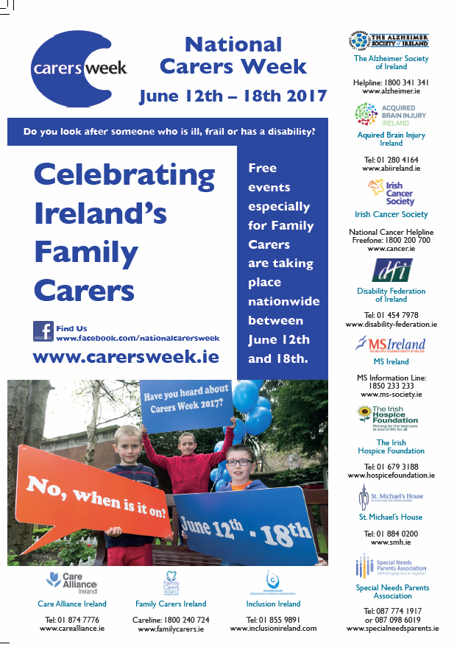 |  | €0.50c
Flyers – A5 size General Carers Week with no space for event details - text on both sides (Previous Years Images only for Ref.) | 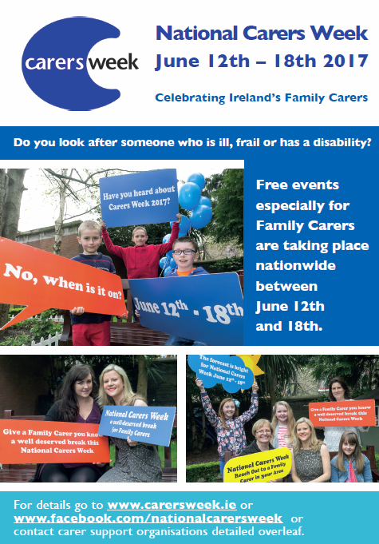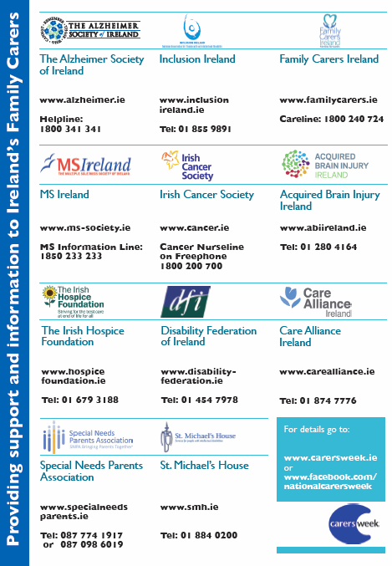 |  | €0.25c
Power-banks, 4000mah, with Micro-USB charging cable  (new item) | 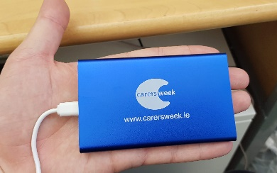 |  | €11.99
Total Cost

Please return the fully completed form, preferably by email to info@carersweek.ie or by post to Care Alliance Ireland, Coleraine House, Coleraine Street, Dublin 7. by May 24th
For queries please call 085 852 9352

